OudhTrade
Functional Requirements (FRS)
Module 1 — Platform Foundation · M01-2
Document details
Company | MRIDA INFRA AND PLANTATIONS LLP
Product | OudhTrade — oudhtrade.com
Document | M01-2 Functional Requirements (FRS)
Module | M01 Platform Foundation (release R1)
Readers | Developers, QA, product owner
Related documents | PRD (PRD-FND, PRD-CMP) · HLD · other M01 documents
Owner | Product owner
Decision owner | T. Satish Reddy, CEO & Founder
Status | Draft for review — 24 September 2026
Classification | Confidential — for partners and the OudhTrade team

Contents
1. How to read this FRS 2
2. Environments & Releases (ENV) 2
3. File & Media Service (FIL) 3
3.1 Photos 3
3.2 Documents 4
3.3 Video 4
3.4 All files 5
3.5 Photo location and photo safety 5
4. Units & Conversion (UNT) 6
5. Languages & Formats (LOC) 7
6. Page Addresses & SEO (URL) 8
7. Audit Log (AUD) 10
8. Configuration & Feature Switches (CFG) 11
9. Events, Jobs & Scheduler (EVT) 12
10. Data Retention & Legal Hold (RET) 13
11. Cookie Consent (CKE) 14
12. API Conventions & Errors (API) 15
13. Monitoring (OBS) 16
14. Country & Currency Reference (CTY) 16
15. Rate Limits (RTL) 17
16. Edge & Application Security (SEC) 18
17. AI Gateway (AIG) 19
18. Settings List (M01) 19

1. How to read this FRS
Each requirement has an ID (M01-FR-<area>-nnn), a priority (Must / Should / Could) and a release. Numbers marked “configurable” are defaults Admin can change without code. Every requirement traces to the PRD (see M01-1 Section 8) and has test cases in M01-7. Every Module 1 setting, with its default, allowed values and approval level, is listed in Section 18.

2. Environments & Releases (ENV)
ID | Requirement | Priority | Release
M01-FR-ENV-001 | Three environments — development, staging, production — each in its own AWS account with separate keys and passwords. | Must | R1
M01-FR-ENV-002 | All infrastructure is created from code (Terraform or AWS CDK); no manual changes in production. | Must | R1
M01-FR-ENV-003 | Build pipeline runs automated tests and security scans on every change; database changes run as a separate controlled step; production releases need approval. | Must | R1
M01-FR-ENV-004 | Feature switches turn features on per release (R1, R2, R3) and per environment without a new deployment; switch changes are logged. | Must | R1
M01-FR-ENV-005 | Staging and development use only made-up data and the demo data set. Production data is never copied to them, not even anonymised; no tool or pipeline step exists to do so. | Must | R1
M01-FR-ENV-006 | Test sites are password-protected, blocked from search engines, send messages only to a test inbox and use the payment gateway’s test mode. | Must | R1
M01-FR-ENV-007 | A demo data set covers all 6 categories, all roles and typical listings, and can be reloaded on staging at any time. | Must | R1
M01-FR-ENV-008 | Configuration can be exported from staging and imported into production (with approval). | Must | R1
M01-FR-ENV-009 | Backups: the database is backed up continuously with point-in-time restore for 35 days (starting value, configurable); daily snapshots are kept; file storage (S3) is copied to Hyderabad by cross-region replication. | Must | R1
M01-FR-ENV-010 | Warm standby and DR plan: the database runs in several zones in Mumbai. A copy in Hyderabad is kept a few seconds behind, with no user traffic; if the Mumbai region fails it is promoted and the site pointed there. The Keycloak database has a cross-region replica in Hyderabad; search (Typesense) is rebuilt from PostgreSQL; Redis starts empty; containers are rebuilt from infrastructure code. Data loss (RPO): 5 minutes within Mumbai; target ≤ 1 minute if the region is lost. Restore time (RTO): 24 hours in R1, 8 hours from R2. A written DR plan is owned by the tech lead. | Must | R1
M01-FR-ENV-011 | Drills: every quarter a production backup (the Hyderabad copy) is restored into an isolated AWS account and the RPO and RTO are timed; every year the Hyderabad standby is promoted in a failover test. Results are reported to the founder and tech lead. | Must | R1
M01-FR-ENV-012 | White-label ready: no brand name, colours or logos are hard-coded; the brand comes from design tokens and configuration. | Must | R1

3. File & Media Service (FIL)

3.1 Photos
ID | Requirement | Priority | Release
M01-FR-FIL-001 | Accepted photo formats: JPG, PNG, WEBP, HEIC; other formats are rejected with a clear message. | Must | R1
M01-FR-FIL-002 | Maximum upload size 15 MB per photo (configurable); checked in the browser before upload and again on the server. | Must | R1
M01-FR-FIL-003 | Each photo is converted to web formats and resized to standard sizes (thumbnail, medium, large); the original is kept privately. | Must | R1
M01-FR-FIL-004 | Location (GPS) and device data are always removed from every public photo variant. | Must | R1
M01-FR-FIL-005 | A listing has 1–10 photos (configurable); the first is the cover; order can be changed by drag and drop. | Must | R1
M01-FR-FIL-006 | Quality check warns (does not block) when a photo is smaller than 800 px on its short side or looks blurred. | Should | R1
M01-FR-FIL-007 | Seller can switch on an OudhTrade watermark for their photos (off by default); the choice is remembered for the account as the default for new photos, each photo keeps its own setting, and the watermark is applied to public variants only. | Should | R1

3.2 Documents
ID | Requirement | Priority | Release
M01-FR-FIL-008 | Accepted document formats (verification documents and other documents): PDF, JPG, PNG, HEIC / HEIF and WEBP; maximum 10 MB per file (configurable). HEIC / HEIF and WEBP files are converted on the server so reviewers can open them; the original is kept privately. | Must | R1
M01-FR-FIL-009 | Documents are stored privately. Only the file’s owner can get a short-lived signed link to it (GET /v1/files/{id}/link); staff see documents only in the watermarked document viewer (M03), never through a signed link. Every opening is written to the audit log. | Must | R1
M01-FR-FIL-010 | Documents are never shown on public pages, never cached by the CDN and never indexed by search engines. | Must | R1

3.3 Video
ID | Requirement | Priority | Release
M01-FR-FIL-011 | One video per listing; formats MP4 or MOV; maximum 100 MB and 60 seconds (both configurable). | Must | R1
M01-FR-FIL-012 | Videos longer than the limit (files.video.max_seconds, default 60) are refused before upload with the message “This video is {length}. Please trim it to {max} seconds or less.” (M01-6 Section 4). | Must | R1
M01-FR-FIL-013 | Each video is converted to a 720p web version and a cover image is created automatically; location data is removed. | Must | R1
M01-FR-FIL-014 | Before upload, the system checks the seller’s video allowance (from Module 11 plan settings; default 2 listings for free plans and farmers). | Must | R1
M01-FR-FIL-015 | A processed video is not shown publicly until a moderator approves it (Module 12); the seller sees its status: processing, in review, live, rejected with reason. | Must | R1
M01-FR-FIL-016 | Videos play muted by default with a sound button; they are delivered through the CDN and load only when played. | Must | R1
M01-FR-FIL-017 | Only verified sellers and verified farmers can upload video. | Must | R1

3.4 All files
ID | Requirement | Priority | Release
M01-FR-FIL-018 | Every file is uploaded to a quarantine area and scanned for malware; it is not used anywhere until the scan passes. Infected files are deleted and the event is logged. | Must | R1
M01-FR-FIL-019 | Files belong to an owner and a purpose (listing photo, verification document, chat attachment…); access follows the purpose’s rules. | Must | R1
M01-FR-FIL-020 | Unused uploads (never attached) are deleted after 7 days (configurable). | Must | R1
M01-FR-FIL-021 | Upload progress, retry on network failure and resume for large files (video) are supported. | Must | R1

3.5 Photo location and photo safety
ID | Requirement | Priority | Release
M01-FR-FIL-022 | Location data (GPS) is kept, in the private original only, for photos whose purpose needs a check: farm-visit photos, verification photos and documents, business-location photos (location_photo) and origin-check photos and documents. For all other purposes (listings, reviews, chat, avatars, logos) it is removed at upload, from the original too. Only staff with the permission photo_location.view (Moderator and Senior Moderator) can see a kept location, for checks (M03 / M06); every view is written to the audit log. When the location is kept, the uploader sees: “Location is never shown publicly. OudhTrade staff may use it to check origin.” | Must | R1
M01-FR-FIL-023 | Every photo and every video cover image is checked for written text and QR codes. If a phone number, email address, UPI ID, web address or QR code is found, the photo is held (not public) and sent to the moderation queue (M12); the seller sees why. | Must | R1
M01-FR-FIL-024 | Every public photo gets a fingerprint. If it matches a photo of another seller (similarity threshold configurable), the photo keeps its status and stays visible, is marked duplicate_suspected, and both listings go to the M12 copied-photo queue. A seller re-using their own photos is allowed. The threshold is tuned on real photos before R1; some heavily edited copies may be missed. | Must | R1
M01-FR-FIL-025 | Fingerprints of photos removed by moderation (copied, stock or banned) are kept on a block list; the same photo cannot be uploaded again. | Should | R1
M01-FR-FIL-026 | Business location media (M03): up to 2 photos (purpose location_photo) and 1 video per business location (purpose location_video) of up to 45 seconds and 45 MB (both configurable); the server compresses the video. They get the same processing and safety checks as listing media — location data removed, text and QR check, fingerprint, malware scan — and are shown publicly only after the safety review; the video is approved by a moderator (Module 12) before it shows. | Must | R1
M01-FR-FIL-027 | Photo location view: staff with the permission photo_location.view (FIL-022) see the kept photo location — the coordinates and the distance to the declared place, worked out on the server — only after giving a reason (a reason from the list and a note, e.g. “Origin check for listing 10482”). Each view writes an audit record with the reason; the location is never copied into other records or exports. Shown inside the M03 verification review (screen A) and the M06 origin-check screens. Screen: M01-6 Section 12.14. | Must | R1
M01-FR-FIL-028 | Face blur: for farm-visit and business-location photos (and any other purpose a module asks for), photo processing finds faces and makes a public copy with them blurred (variant “blurred”); every public size is made from that copy. Staff add or fix blur boxes by hand on the Module 3 farm-visit review screen (M03-AD-03) before approving; the private original is never shown publicly. If no face check could run, the photo stays private until a person checks it. | Must | R1

4. Units & Conversion (UNT)
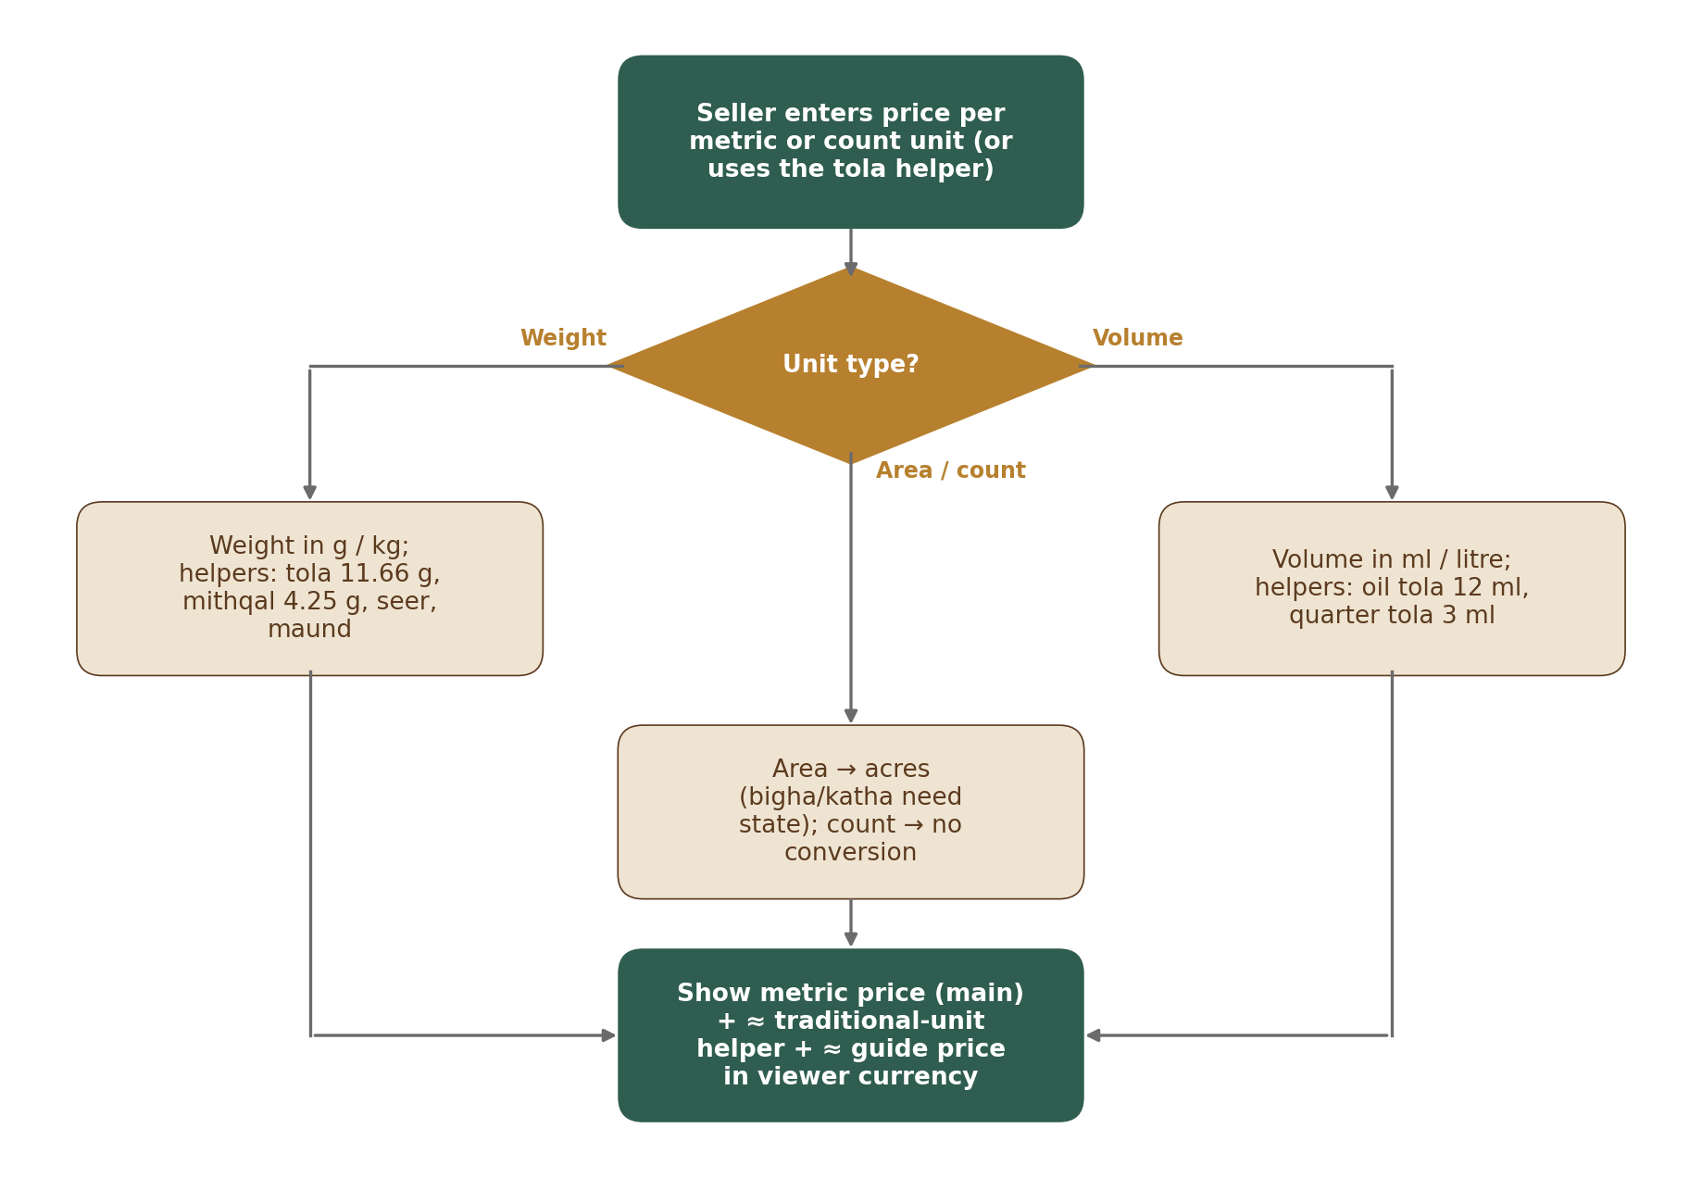
Figure 1 — How a listing unit is converted for display
Type | Unit | Standard unit | Factor (default)
Weight | gram / kg / quintal / tonne | gram | 1 / 1,000 / 1,00,000 / 10,00,000
Weight | tola (wood, chips, powder) | gram | 11.66
Weight | mithqal | gram | 4.25
Weight | seer / maund | gram | 933 / 37,320 (maund = 40 × 933 g)
Volume | ml / litre | ml | 1 / 1,000
Volume | tola (oil) | ml | 12
Volume | quarter tola (oil) | ml | 3
Count | piece, stick, packet, box, bottle, plant, tree | — | No conversion
Area | acre / hectare / m² | m² | 4,046.86 / 10,000 / 1
Area | bigha, katha, lessa | m² | Per state (state land-unit table, UNT-009)

ID | Requirement | Priority | Release
M01-FR-UNT-001 | The unit list and every factor are data managed by Admin on the units screen (M01-6 Section 12.13, in the Configuration Console shell, M16); changes are versioned and logged. | Must | R1
M01-FR-UNT-002 | Tola has two meanings: weight (11.66 g) for wood, chips and powder; volume (12 ml) for oil. The item’s type decides which is used. | Must | R1
M01-FR-UNT-003 | Bigha, katha and lessa require the seller to choose the state; the area is also shown in acres. If no factor exists for that state, the unit cannot be chosen. | Must | R1
M01-FR-UNT-004 | Prices are entered and shown per standard metric unit (g, kg, quintal, tonne, ml, litre) or per count unit (piece, packet…). Tola, mithqal, seer and maund are shown only as a smaller helper line, e.g. “≈ ₹6,000 per tola” (Legal Metrology Act 2009, Section 11 — counsel to confirm). Listing prices are never converted between currencies (guide price: CTY-006). | Must | R1
M01-FR-UNT-005 | Oil volume and weight are never converted into each other (ml ↔ g). | Must | R1
M01-FR-UNT-006 | Conversions are calculated with enough precision and shown rounded (≈ sign) to 2 decimals for money and 2 significant decimals for quantities. The guide price (a currency conversion, CTY-006) is rounded to 2 significant figures. | Must | R1
M01-FR-UNT-007 | The listing form has a price helper: the seller may type a price per tola (or other traditional unit) and the form fills in the metric price. Only the metric price is stored. | Must | R1
M01-FR-UNT-008 | Which helper units are shown is set per viewer country (e.g. tola for India and the Gulf, mithqal for the Gulf); configurable on the units screen (Helper units tab). | Must | R1
M01-FR-UNT-009 | State land-unit table: bigha, katha and lessa have a factor per state. Starting values (configurable): Assam — 1 bigha = 14,400 sq ft (1,337.8 m²), 1 katha = 2,880 sq ft (267.56 m²), 1 lessa = 144 sq ft (13.378 m²); West Bengal — 1 bigha = 14,400 sq ft (1,337.8 m²), 1 katha = 720 sq ft (66.89 m²). Admin adds other states only after checking that state’s land records, and records which record was checked. Changes use the common settings pattern (M01-6 Section 12.1). Screen: M01-6 Section 12.13. | Must | R1

5. Languages & Formats (LOC)
ID | Requirement | Priority | Release
M01-FR-LOC-001 | All user-facing text comes from a translation store with keys; English at launch; missing translations fall back to English. | Must | R1
M01-FR-LOC-002 | Layouts support right-to-left languages (Arabic) without redesign; tested with a sample RTL language before R2. | Must | R1
M01-FR-LOC-003 | Numbers: Indian grouping (1,00,000) for India-based users; international grouping (100,000) for others; the user can switch in settings. | Must | R1
M01-FR-LOC-004 | Large amounts in words: lakh / crore for Indian style (₹1.5 lakh, ₹2 crore); K / M for international style (₹150K, $2M). | Must | R1
M01-FR-LOC-005 | Dates shown as “24 Sep 2026” for everyone; times in the user’s time zone with the zone shown where it matters (e.g. deadlines). | Must | R1
M01-FR-LOC-006 | Service-target timers (e.g. 24 business hours) are calculated in IST business hours (Mon–Sat 09:00–19:00), skipping holidays in the holiday calendar (LOC-012). Legal timers (complaints, lawful orders) count calendar hours, not business hours. | Must | R1
M01-FR-LOC-007 | Currency is always shown with its symbol or ISO code (₹, $, AED …); amounts are always stored with their currency code. | Must | R1
M01-FR-LOC-008 | Language order after English: Arabic; then Hindi, Assamese and Bengali; then Chinese and Japanese. Fonts and layouts support Arabic, Devanagari, Bengali-Assamese and Chinese / Japanese scripts. | Must | R1
M01-FR-LOC-009 | Phone numbers are stored in international format (+ country code) and checked with a standard phone-number library for every country. | Must | R1
M01-FR-LOC-010 | Names are stored as entered in any script (no first-name / last-name assumption); addresses follow the layout of the country from the Country table. | Must | R1
M01-FR-LOC-011 | A shared trade-term word list links names used across languages and markets (e.g. agarwood, oud, agar, aloeswood, gaharu, jinko, chen xiang, xasi / sanchi, bakhoor, and grade names such as Double Super). Filled by M04; used by M07 search. | Should | R1
M01-FR-LOC-012 | Holiday calendar: the IST business-hours calculator skips holidays from a calendar managed in Admin (business_holidays table). | Must | R1
M01-FR-LOC-013 | Holiday calendar screen: staff see a year view per country, add or retire a holiday, or import a whole year from a file (the file is refused whole if any row is wrong). Before approval the preview shows how many open service-target timers would change their due time, with an example. Screen: M01-6 Section 12.6. | Must | R1

6. Page Addresses & SEO (URL)
Page | Address pattern
Listing | oudhtrade.com/listing/<title-words>-<listing-number>
Storefront | oudhtrade.com/store/<web-address> (made from the business name, URL-002)
Category / sub-category | oudhtrade.com/<category>/<sub-category>
Guide | oudhtrade.com/guides/<topic>
Other languages (later) | oudhtrade.com/<language>/… (e.g. /ar/, /hi/)

ID | Requirement | Priority | Release
M01-FR-URL-001 | Listing addresses end with the listing number; if the title changes, the old address redirects permanently to the new one. | Must | R1
M01-FR-URL-002 | Store web address: the business name follows M03 (3–60 characters, any script); the web address of the store is made from it: 3–40 characters, lower-case a–z, 0–9 and hyphens, unique, checked against reserved_names (URL-008). A name in another script is transliterated; when that gives no usable address, the seller gets suggestions. The seller may edit the address within these rules. The address is stored once, in url_slugs, and other modules read it through UrlService. | Must | R1
M01-FR-URL-003 | A business name can be changed once per 90 days (configurable; rule owned by M03). M03 changes the name and emits profile.renamed; Module 1 (UrlService) then makes the new web address and redirects the old address permanently. The storefront shows “Formerly {old name}” for 90 days (M03). | Must | R1
M01-FR-URL-004 | One site for all countries; no country sub-sites. | Must | R1
M01-FR-URL-005 | Sitemaps list public listings, storefronts, categories and guides; updated daily. | Must | R1
M01-FR-URL-006 | Opportunity pages, private pages, dashboards and test sites are marked “do not index” and excluded from sitemaps. | Must | R1
M01-FR-URL-007 | Public pages include page titles, descriptions, share previews (for WhatsApp and social media) and structured product data. | Should | R1
M01-FR-URL-008 | Reserved names: business names and page addresses cannot use reserved, banned or protected brand names from the reserved_names list, which Admin manages. | Must | R1
M01-FR-URL-009 | Reserved-name check on existing names: when staff add a name to the reserved_names list, the screen lists the existing business names and page addresses that match it before the change is sent for approval. Existing stores are not renamed automatically; each match is reported to M12 as a moderation case of type reserved_name_match. Screen: M01-6 Section 12.5. | Must | R1

7. Audit Log (AUD)
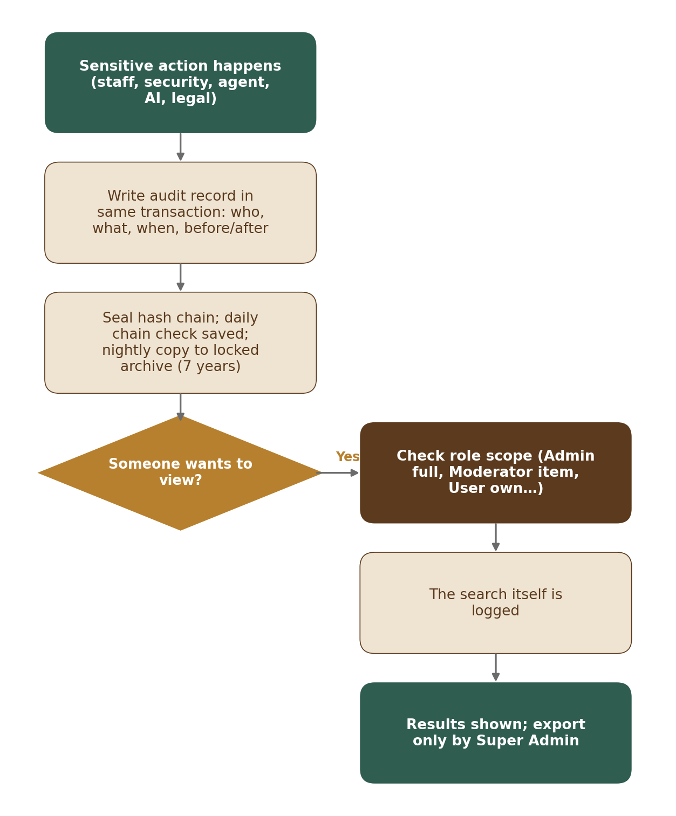
Figure 2 — Audit log write and access
ID | Requirement | Priority | Release
M01-FR-AUD-001 | Recorded actions: staff decisions (approve, reject, ban, refund, config change), security events, field-agent actions, AI flags and suggestions, legal orders, private-document views, data exports. | Must | R1
M01-FR-AUD-002 | Each record holds: time, actor (and role), action, target, reason, before and after values, IP / device, and a link to the previous record so tampering can be detected. | Must | R1
M01-FR-AUD-003 | Records are written in the same transaction as the action; nobody (including Super Admin) can edit or delete them. | Must | R1
M01-FR-AUD-004 | Records are kept 7 years; older records are copied nightly to a locked archive. | Must | R1
M01-FR-AUD-005 | Viewing: Super Admin and Admin search all; Moderator sees history of the item or account under review; Finance sees payment, refund and invoice records; Support sees an account summary without private documents; users see their own account activity; field agents see their own actions (My actions in the agent app, M02). | Must | R1
M01-FR-AUD-006 | Every search of the audit log is itself recorded. | Must | R1
M01-FR-AUD-007 | Only Super Admin can export audit records (e.g. for police or legal cases); the export is recorded. | Must | R1
M01-FR-AUD-008 | Audit log viewer: staff search by time, actor, action and target within their role (AUD-005). A record’s detail shows before and after values and the result of the chain check (whether the record’s link to the previous record is intact). The viewer has no edit or delete action; export needs a reason. Screen: M01-6 Section 12.9. | Must | R1

8. Configuration & Feature Switches (CFG)
ID | Requirement | Priority | Release
M01-FR-CFG-001 | Modules read settings through one configuration interface; values are cached and refreshed within 60 seconds of a new version being published. | Must | R1
M01-FR-CFG-002 | Every setting has a safe default in code so the platform runs if configuration is missing. | Must | R1
M01-FR-CFG-003 | Feature switches can target a release, an environment, a role, a plan, a category, a country or a list of accounts. Each environment has its own console; switches move between environments by export / import (ENV-008). | Must | R1
M01-FR-CFG-004 | Any setting can have overrides by account list, role, plan, category or country; every override is logged. The precedence order is in CFG-005. | Must | R1
M01-FR-CFG-005 | Settings precedence: account list → role → plan → category → country → global. The most specific value wins. | Must | R1
M01-FR-CFG-006 | Publish and approval: settings are published only through ConfigService.publish, called by the Configuration Console (M16) after approval. The settings screens are in M01-6 Section 12; approved settings can also move from staging by export / import (ENV-008), using the same publish step and approval. Every change needs a second person who is not the editor, at two levels: a high-impact change needs a Super Admin; any other change needs any other Admin. The approval rule is in M01-6 Section 12.1 (the one source); each setting’s level is in the settings register (Section 18). The only exception is the emergency path (CFG-010). Every publish and rollback is versioned and audited, and Module 1 then emits config.published. | Must | R1
M01-FR-CFG-007 | Edit conflicts: records edited by staff carry a row version (row_version); a save on a record that someone else changed is refused with a clear message (“Changed by someone else — please reload”). | Must | R1
M01-FR-CFG-008 | Preview impact: before a draft is sent for approval, the system shows what changes (each old value → new value, with its scope), who is affected (counts of accounts, listings, countries or open timers, where they can be worked out) and one worked example. The approver sees the same preview, refreshed. Pattern: M01-6 Section 12.1. | Must | R1
M01-FR-CFG-009 | Scheduled publish, history and rollback: an approved change is published at once or at a chosen date and time, and a scheduled change can be cancelled until it runs. Every version keeps who made it, who approved it, when it was published and why; a reason is required for every draft sent, approval, rejection, cancel and rollback. Staff can roll back to any earlier version; the rollback is a new draft that goes through the same approval (M01-6 Section 12.1). | Must | R1
M01-FR-CFG-010 | Emergency path: one Super Admin, or the on-call engineer, can at once switch a production feature OFF or turn under-attack mode ON without waiting for approval (permission settings.emergency_off). A reason is required; the change is published at once, audited, and an alert goes to all Super Admins. A second Super Admin reviews it within 24 hours. Turning the feature back ON, or under-attack mode OFF, uses the normal approval (CFG-006). Screens: M01-6 Sections 12.1, 12.3 and 12.7. Maintenance mode has its own rule (CFG-012). | Must | R1
M01-FR-CFG-011 | Simple lists: short Admin-managed lists that other modules use in their forms, kept in tag_groups and tags (M01-5 Sections 8.5 and 8.6). Groups at launch (key — use): site_type — business site types (M03 sites); link_platform — platforms for profile links (M03); capacity_unit — capacity units (M03 capabilities); service_technique — service techniques (M03 capabilities; the only group whose items may have a parent). The starting items of each group are set by the module that uses it (M03-2). A group is added only with the design of the module that uses it; staff cannot add or remove groups. On the Simple lists screen (M01-AD-14, M01-6 Section 12.15) staff add, rename, reorder, set a parent (only in a group that allows parents; one level) and retire items, using the common settings pattern; these are “other” changes. An item key never changes and is never reused; a retired item is no longer offered, but records that already use it keep it and still show its name; a parent with active items cannot be retired. Products, species and document types are not simple lists: they stay in the M04 taxonomy and the M03 document checklists. | Must | R1
M01-FR-CFG-012 | Maintenance mode (setting platform.maintenance_mode: off, full or read-only; high impact) is set on Feature switches (M01-6 Section 12.3); what users and staff see while it is on is in API-009. Start now: only a Super Admin (not the on-call engineer) chooses full or read-only, the expected-back time (maintenance.expected_back_at, optional) and a reason; it is live at once, audited, and an alert goes to all Super Admins; a second Super Admin reviews it within 24 hours on the Changes screen, as in CFG-010. Planned: a Super Admin prepares it with the start time, the mode and the expected-back time; the screen suggests the next weekly maintenance window (Wednesday 02:00–04:00 IST, NFR N1; another time needs a reason); a second Super Admin approves; it starts by itself at that time (CFG-009); users see a notice from maintenance.notice_hours before the start (48 hours by default, as in PRD-NFR-003) and the status page announces it. End: any one Super Admin ends it at once with a short note; no second approval is needed, so the site is never kept closed while waiting; audited. | Must | R1

9. Events, Jobs & Scheduler (EVT)
ID | Requirement | Priority | Release
M01-FR-EVT-001 | Events are written to the outbox in the same transaction as the change and delivered at least once; handlers must be safe to run twice. | Must | R1
M01-FR-EVT-002 | Background jobs retry with increasing delay; after the last retry they move to a failed list that staff can review and re-run. | Must | R1
M01-FR-EVT-003 | The scheduler runs timed tasks (expiry, reminders, trust updates, retention, sitemaps, quarterly user notice) and records each run. | Must | R1
M01-FR-EVT-004 | Alerts fire when the outbox or job backlog is older than 5 minutes (configurable). | Must | R1
M01-FR-EVT-005 | Failed jobs screen: staff see jobs that are still retrying and jobs in the dead-letter list (all retries used), with the last error. They can retry one job or up to 100 jobs of one kind, or discard a dead job with a reason. Every retry and discard is written to the audit log. Screen: M01-6 Section 12.11. | Must | R1

10. Data Retention & Legal Hold (RET)
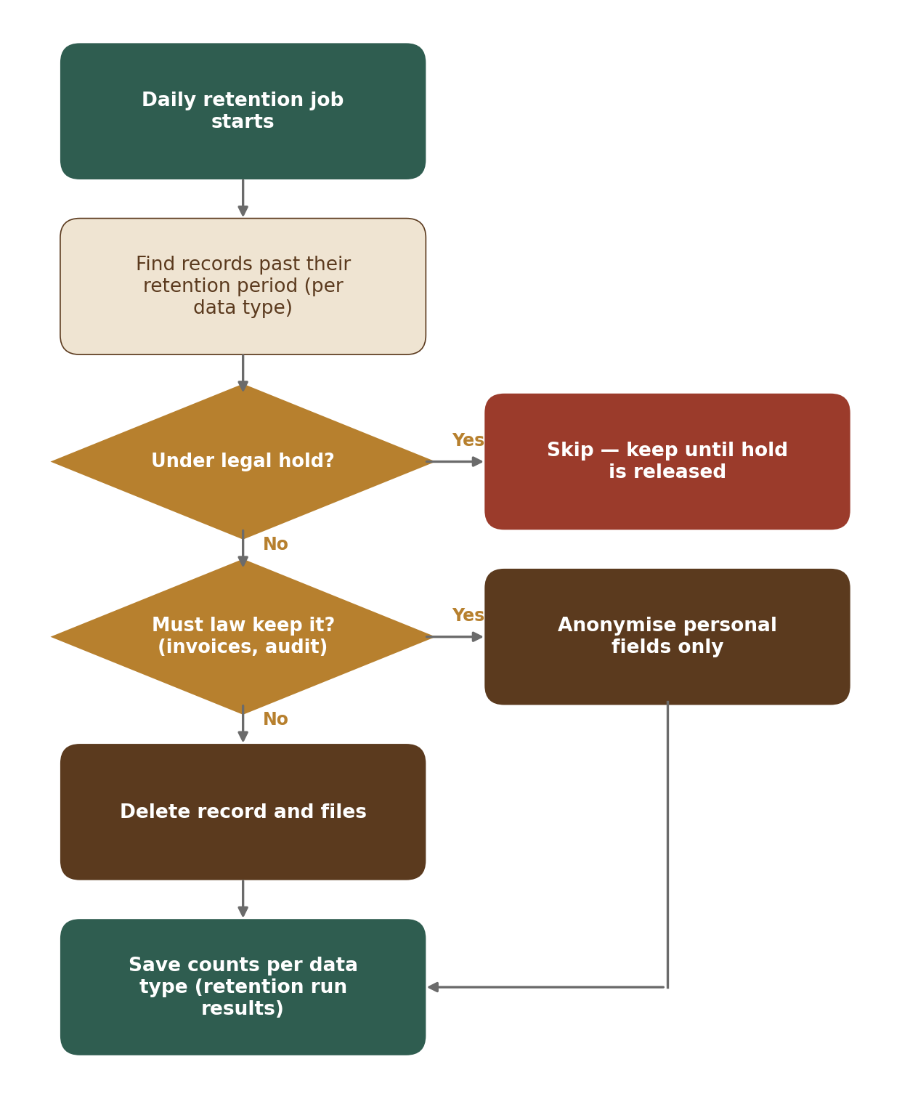
Figure 3 — Daily retention job
ID | Requirement | Priority | Release
M01-FR-RET-001 | A retention period is set per data type (e.g. unused uploads 7 days, closed accounts 30 days then anonymised, chat after account closure per counsel, invoices 8 years, audit log 7 years, security logs ≥ 180 days, processing logs ≥ 1 year) [TBC: final periods with counsel]. | Must | R1
M01-FR-RET-002 | A daily job deletes or anonymises data past its period, keeps what the law requires, and writes a report. | Must | R1
M01-FR-RET-003 | Legal hold (set by Admin for a legal order or dispute) stops deletion of all linked data until released; setting and releasing a hold is logged. | Must | R1
M01-FR-RET-004 | Legal hold screen: staff see all holds (active and released) with scope, reason, reference and who placed them. Placing and releasing a hold both need a reason. Before a release, the screen shows what the next daily retention run would then delete or anonymise. Screen: M01-6 Section 12.10. | Must | R1
M01-FR-RET-005 | Retention policies screen: each data type shows its period, action (delete or anonymise), legal basis and the holds that affect it. Period changes are high-impact settings and use the common settings pattern (M01-6 Section 12.1). A period can never be set shorter than the legal minimum stored for that data type. Screen: M01-6 Section 12.12. | Must | R1

11. Cookie Consent (CKE)
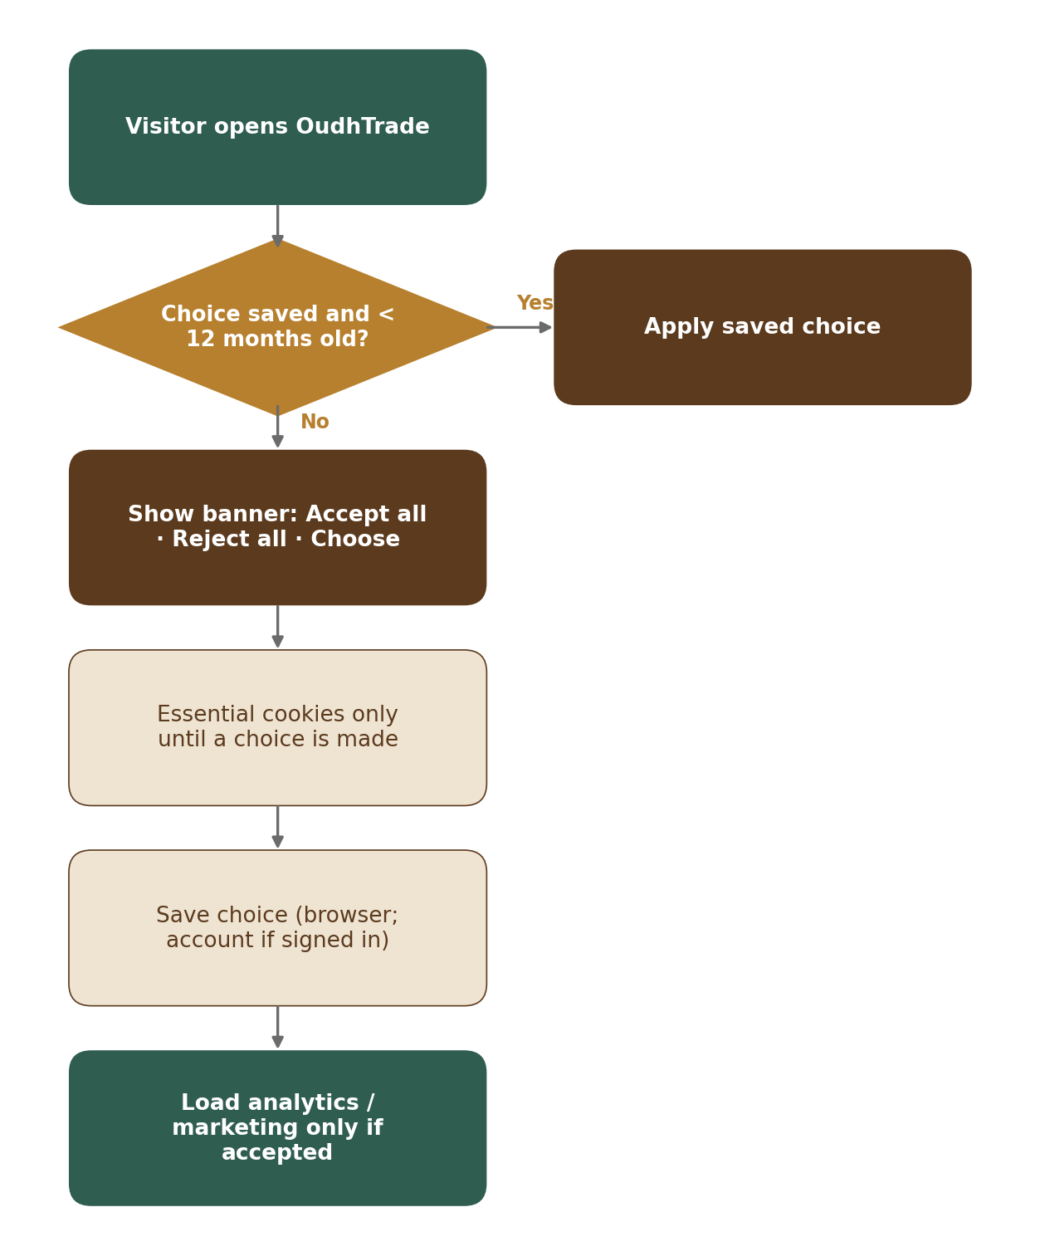
Figure 4 — Cookie consent flow
ID | Requirement | Priority | Release
M01-FR-CKE-001 | Essential cookies are always on; analytics and marketing cookies and tags load only after consent. | Must | R1
M01-FR-CKE-002 | Banner buttons “Accept all”, “Reject all” and “Choose” have equal size and prominence; no pre-ticked boxes. | Must | R1
M01-FR-CKE-003 | The same banner and rules apply to all countries. | Must | R1
M01-FR-CKE-004 | A “Cookie settings” footer link lets visitors change their choice at any time. | Must | R1
M01-FR-CKE-005 | The choice is remembered for 12 months, then asked again; for signed-in users it is saved to the account and applied on web and apps. | Must | R1
M01-FR-CKE-006 | Consent records (choice, time, banner version) are stored as proof. | Must | R1
M01-FR-CKE-007 | Cookie-free KPI counts: key counts (page views, listing views, enquiries, sign-ups) are counted on the server without cookies or personal identifiers. | Must | R1

12. API Conventions & Errors (API)
ID | Requirement | Priority | Release
M01-FR-API-001 | All APIs are versioned (/v1) and described in an OpenAPI contract shared by web, apps and admin. | Must | R1
M01-FR-API-002 | Errors use one format with a code, a user-friendly message (translated) and a request ID for support. | Must | R1
M01-FR-API-003 | Lists are paginated; requests are rate-limited — per account for signed-in users, per IP / device for visitors — with a clear “please try again later” message. | Must | R1
M01-FR-API-004 | Friendly error pages: page not found (404) with a search box and help link; something went wrong (500) with Try again and a help link; the maintenance page with the expected-back time (setting maintenance.expected_back_at), the read-only banner, the planned-maintenance notice and a status link (M01-6 Section 10). | Must | R1
M01-FR-API-005 | Idempotency keys: writes that create records or charge money accept an Idempotency-Key header. The first response is stored for 24 hours (idempotency_keys table) and returned again for repeats, so a retried request never creates a second record or charge. | Must | R1
M01-FR-API-006 | Rate-limit headers: responses carry RateLimit-Limit, RateLimit-Remaining and RateLimit-Reset; a refused request gets HTTP 429 with Retry-After. | Must | R1
M01-FR-API-007 | Pagination: lists use cursor paging; 20 items by default, at most 100; the response gives the next cursor. | Must | R1
M01-FR-API-008 | Deprecation: an old API version is supported for at least 6 months after its replacement; responses carry Deprecation and Sunset headers; the change is announced in release notes. | Must | R1
M01-FR-API-009 | Maintenance behaviour (CFG-012). Full: every user page and the apps show the maintenance page; API calls get HTTP 503 MAINTENANCE with Retry-After and the expected-back time; background work is paused (workers take no new jobs; emails, SMS and notifications wait in the queue; scheduled runs wait) and continues by itself when maintenance ends, so nothing is lost. Read-only: people can open pages, search, view listings and profiles and sign in; every change (sign-up, posting, editing, messages, uploads, payments) is refused with HTTP 503 READ_ONLY_MODE and the read-only banner; background work keeps running. In both modes the admin console is open only to Super Admins, who work normally; other staff see the maintenance page. The maintenance page and the banners read a small status file on the CDN, so they work while the API is down (M01-3 Section 4). | Must | R1

13. Monitoring (OBS)
ID | Requirement | Priority | Release
M01-FR-OBS-001 | Every request carries a request ID visible in logs and error messages. | Must | R1
M01-FR-OBS-002 | Dashboards and alerts for availability, error rate, response time, job backlog, file-processing failures and security events. | Must | R1
M01-FR-OBS-003 | Security logs are kept in India for at least 180 days (CERT-In). | Must | R1
M01-FR-OBS-004 | Automatic speed checks every 5 minutes from Mumbai, Dubai and Singapore; target: main pages usable ≤ 2.5 s in India and ≤ 3 s elsewhere. | Must | R1
M01-FR-OBS-005 | Monthly cloud budget [TBC: tech lead AWS estimate from the HLD sizing] (configurable) with alerts at 50 %, 80 % and 100 % to the founder and tech lead, a cost-per-service report and alerts for unusual spending. | Must | R1
M01-FR-OBS-006 | A public status page (status.oudhtrade.com), hosted separately from the main platform, shows service status, incidents and planned maintenance; error pages link to it. | Must | R1
M01-FR-OBS-007 | Personal-data processing logs are kept for at least 1 year in a locked log archive in India. | Must | R1
M01-FR-OBS-008 | Application logs are searchable for 30 days and archived for 1 year, in India. | Must | R1
M01-FR-OBS-009 | Real-user monitoring: page speed (Largest Contentful Paint, Interaction to Next Paint, Cumulative Layout Shift, 75th percentile) is measured in real visitors’ browsers against the targets in NFR, Section 3, together with the synthetic checks (OBS-004). It sets no cookies and collects no personal identifiers. | Must | R1

14. Country & Currency Reference (CTY)
ID | Requirement | Priority | Release
M01-FR-CTY-001 | One Country table for all modules: ISO country code, name (translated), market region (e.g. Gulf; M01-5 Section 5.1), phone code, currency, guide currency, default language, number style, time zones, weekend days, address layout, status and allowed features. Managed in the Country table screen (M01-6 Section 12.4); versioned and logged. | Must | R1
M01-FR-CTY-002 | States and regions (full ISO 3166-2 codes, e.g. IN-AS) for India and other countries where needed, and India districts (LGD codes); used by addresses, listings, profiles, lots, bigha / katha factors and documents per state. | Must | R1
M01-FR-CTY-003 | Country status: allowed, restricted (listed features switched off) or blocked (sanctioned; list set with counsel). Blocked status is used at the edge (SEC-004) and at sign-up (M02). | Must | R1
M01-FR-CTY-004 | Country feature rules (e.g. Opportunities visible, export listings visible) are read by modules through one interface. | Must | R1
M01-FR-CTY-005 | Exchange rates for the guide currencies are fetched daily from an approved provider [TBC: provider] and stored with date and source. If fetching fails, the last rates are used; an alert fires after 24 hours, and after 48 hours the guide price is hidden. Staff see the current rates with their date and source, and whether the guide price is shown, on the Exchange rates tab of the Country table (M01-AD-03; view only). | Must | R1
M01-FR-CTY-006 | Guide price: under a listing price, the price is also shown in the viewer’s guide currency, e.g. “≈ AED 270 (guide only)”. It is never used for sorting, filtering, billing or quotations. The viewer can change the guide currency or switch it off. | Must | R1
M01-FR-CTY-007 | Guide currencies (configurable): AED, SAR, QAR, KWD, OMR, BHD, SGD, MYR, IDR, THB, VND, HKD, TWD, CNY, JPY, KRW, EUR, GBP, plus INR and USD. | Must | R1
M01-FR-CTY-008 | The Country table holds the OTP channel order, allowed sign-in methods, whether the SMS sender name is registered (yes / no) and the daily OTP cost cap per country (used by M02). Channel values: sms, whatsapp, email and voice (voice-call codes). Examples: India {sms, voice, whatsapp, email} — SMS, then voice-call codes (e.g. for farmers), then WhatsApp, then email; most other countries WhatsApp, then SMS, then email; China SMS then email, with Google sign-in not allowed. Daily OTP cost cap per country (starting values, configurable): 0 for countries not open for sign-up (no codes are sent there); India INR 3,000 a day; each other open country USD 50 a day. One more global daily cap covers all countries together [TBC: value with the budget estimate]. An alert goes to Finance and on-call at 80 % of any cap; when a cap is reached, M02 sends no more codes under it that day. Changes take effect without a code release. | Must | R1

15. Rate Limits (RTL)
ID | Requirement | Priority | Release
M01-FR-RTL-001 | One shared rate-limit service is used by every module. A limit is defined by who (visitor IP / device, account, plan), what (action group) and time window. Signed-in users are always limited per account, never per IP, so people behind one office or mobile-network IP do not block each other; visitors are limited per IP / device. | Must | R1
M01-FR-RTL-002 | Limits are settings with safe defaults (M01-3 Section 10) and can be overridden by plan, role and country. | Must | R1
M01-FR-RTL-003 | When a limit is reached the user gets a friendly, translated message with the waiting time, e.g. “You’re doing this too often. Please try again in 2 minutes.” (HTTP 429 with Retry-After). | Must | R1
M01-FR-RTL-004 | Staff, approved partner API keys and genuine search-engine crawlers (checked by reverse DNS) have their own limits. | Must | R1
M01-FR-RTL-005 | Repeated breaches lead first to a challenge (visitors) and then to a temporary block (default 15 minutes) and a security event; a visitor is never blocked before a challenge. Permanent blocks are set only by staff, on the Blocks screen (M01-AD-15): staff see the current blocks (automatic and permanent), block one key and lift a block; a reason is required and every change is audited. | Must | R1
M01-FR-RTL-006 | Each module lists its own limits in its document 3 and registers them with the service. | Must | R1
M01-FR-RTL-007 | If the rate-limit store is unavailable, browsing continues with per-server limits, but sensitive actions (uploads, sign-in, OTP, contact reveal) are refused until it is back. | Must | R1

16. Edge & Application Security (SEC)
ID | Requirement | Priority | Release
M01-FR-SEC-001 | A web application firewall in front of the site with managed rules for common attacks, known bad inputs and IP reputation; all blocks are logged. | Must | R1
M01-FR-SEC-002 | Bot protection and anti-scraping: bot detection, page-view limits per visitor on listing and store pages, a challenge for suspicious traffic; genuine search engines (checked by reverse DNS) allowed. | Must | R1
M01-FR-SEC-003 | Seller contact details are never included in public page code or sitemaps; they are revealed only through the owning module’s rate-limited, logged API. | Must | R1
M01-FR-SEC-004 | Visitors from blocked (sanctioned) countries are stopped at the edge with a clear page, using the Country table. | Must | R1
M01-FR-SEC-005 | HTTPS only (HSTS), TLS 1.2 or higher; security headers (content security policy, frame protection, content-type, referrer and permissions policies); cookies Secure, HttpOnly and SameSite; cross-site requests only from OudhTrade domains; protection against cross-site request forgery on forms. | Must | R1
M01-FR-SEC-006 | Data encrypted at rest with managed keys rotated yearly; secrets kept in a secrets manager and rotated automatically every 90 days where supported; no secrets in code or logs. | Must | R1
M01-FR-SEC-007 | All server clocks are synced to NIC / NPL time servers or sources traceable to them (CERT-In) [TBC: counsel to confirm source]. | Must | R1
M01-FR-SEC-008 | Cyber incidents of the types listed by CERT-In are reported within 6 hours, using an incident runbook and a named point of contact. | Must | R1
M01-FR-SEC-009 | Standard protection against denial-of-service attacks, with a stricter “under attack” mode that can be switched on by a feature switch — at once through the emergency path (CFG-010). | Must | R1
M01-FR-SEC-010 | Security contact: a “Report a security issue” page and /.well-known/security.txt are live from R1 (text by M17, publishing by Module 1). | Must | R1
M01-FR-SEC-011 | Upload size is enforced at storage: each upload link carries the size limit for its purpose (pre-signed POST with content-length-range); uploads that are never confirmed are deleted after 24 hours. | Must | R1

17. AI Gateway (AIG)
Module 1 owns the AI gateway (tables ai_requests and ai_budgets in the platform schema). The AI features themselves belong to other modules (M05, M07, M09, M12, M17); search embeddings are stored in the M07 schema.
ID | Requirement | Priority | Release
M01-FR-AIG-001 | All AI calls from any module go through the AI gateway; the provider and model can be switched in configuration without code changes. | Must | R1
M01-FR-AIG-002 | Data rule: Restricted data (ID and document numbers, verification documents, photo location, passwords, keys, audit log) and contact details are blocked before sending. One exception (PRD-AI-006): the text of a foreign-language verification document may be sent for translation for the reviewer only after ID and document numbers are removed; images of IDs and selfies are never sent. Other personal data is sent only when the purpose allows it, and minimised. The provider must be listed in the cross-border register; an India-hosted model is preferred. | Must | R1
M01-FR-AIG-003 | Every AI call is logged in ai_requests: module, purpose, provider, model, tokens, cost, data level sent and result. | Must | R1
M01-FR-AIG-004 | Monthly cost budgets per module and purpose (ai_budgets) with alerts at 80% and 100%; at 100% non-essential AI features pause. Monthly total [TBC: tech lead AWS estimate from the HLD sizing] (configurable), split by purpose — moderation 40 %, translation 30 %, search 20 %, other 10 %. | Must | R1
M01-FR-AIG-005 | AI output shown to users is labelled. AI never approves, bans, verifies or changes trust by itself (PRD-GEN-009). | Must | R1
M01-FR-AIG-006 | AI usage and budgets screen: per module and purpose, staff see calls, tokens and cost this month against the budget, the alert state (80 % or 100 %) and whether the purpose is paused. Budget changes are high-impact settings and use the common settings pattern; a paused purpose starts again when a raised budget is published or the next month starts. Screen: M01-6 Section 12.8. | Must | R1

18. Settings List (M01)
Every value Module 1 lets staff change, generated from the settings register (Cross-Module Registers, sheet Settings). Only settings in the register exist; each has its approval level there (High or Other, M01-6 Section 12.1). A new setting is added to the register with its level when it is designed. “<…>” in a key stands for one row per module, purpose, country, data type or name.
Key | Name — what it controls | Default | Allowed | Unit | Level | Screen
files.photo.max_mb | Largest photo — Largest photo a user can upload | 15 | 1–50 | MB | High | M01-AD-01
files.listing.photos_max | Photos per listing — Photos on one listing (the first is the cover) | 10 | 1–30 | photos | High | M01-AD-01
files.photo.quality_min_px | Small-photo warning size — Short side below which the “small photo” warning shows | 800 | 320–2,000 | px | Other | M01-AD-01
files.document.max_mb | Largest document — Largest document | 10 | 1–25 | MB | High | M01-AD-01
files.video.max_mb | Largest listing video — Largest listing video | 100 | 10–500 | MB | High | M01-AD-01
files.video.max_seconds | Longest listing video — Longest listing video | 60 | 10–180 | seconds | High | M01-AD-01
files.location_photo.max_per_location | Photos per business location — Photos per business location | 2 | 0–5 | photos | High | M01-AD-01
files.location_video.max_mb | Largest location video — Largest business-location video (the server compresses it) | 45 | 5–100 | MB | High | M01-AD-01
files.location_video.max_seconds | Longest location video — Longest business-location video | 45 | 10–60 | seconds | High | M01-AD-01
files.signed_link.valid_minutes | Private file link life — How long an owner’s signed link to a private file works | 5 | 1–15 | minutes | High | M01-AD-01
files.decode.max_megapixels | Largest image to decode — Largest image the worker will decode | 40 | 10–100 | megapixels | Other | M01-AD-01
files.decode.max_side_px | Longest image side to decode — Longest image side the worker will decode | 12,000 | 4,000–20,000 | px | Other | M01-AD-01
files.decode.memory_mb | Decode memory cap — Memory cap for one decode | 1,024 | 256–4,096 | MB | Other | M01-AD-01
files.decode.timeout_heic_s | HEIC decode time-out — Decode time-out for HEIC and HEIF images | 15 | 5–60 | seconds | Other | M01-AD-01
files.decode.timeout_other_s | Other image decode time-out — Decode time-out for other image formats | 10 | 5–60 | seconds | Other | M01-AD-01
files.copy_match.max_distance | Copied-photo match distance — Most differing fingerprint bits still treated as a copy (tuned on real photos before R1) | 3 | 0–8 (above 3 the band search can miss some matches) | bits | Other | M01-AD-01
agent_app.offline_queue_days | Agent offline queue wipe — Days before the field-agent offline queue is wiped | 7 | 1–14 | days | High | M01-AD-01
jobs.backlog_alert_minutes | Job backlog alert — Alert when the outbox or job backlog is older than this | 5 | 1–60 | minutes | Other | M01-AD-01
outbox.keep_days | Delivered events kept — Days delivered events and processed-event rows are kept | 30 | 7–90 | days | Other | M01-AD-01
rate_limit.<module>.<action_group> | Rate limit per action group — Limit, time window and action on breach for one action group (signed-in users per account, visitors per IP / device) (owner: Module that registers the group) | Per group: M01-3 Section 10 (Module 1 groups); each module’s document 3 | Limit: whole number above 0; window 1 s–1 day; on breach: ordered steps from wait, challenge, slow_down, ignore, block, security_event | requests per window | High | M01-AD-06
rate_limit.block_minutes | Block length after breaches — Temporary block after repeated breaches (visitors get a challenge first) | 15 | 5–1,440 | minutes | High | M01-AD-06
fx.alert_after_hours | Exchange-rate alert delay — Alert when no new exchange rates arrived for this long | 24 | 6–72 | hours | Other | M01-AD-01
fx.hide_after_hours | Hide guide price after — Guide price hidden when the rates are older than this | 48 | 24–168 | hours | Other | M01-AD-01
countries.guide_currencies | Guide currencies offered — Currencies offered as guide currency | AED, SAR, QAR, KWD, OMR, BHD, SGD, MYR, IDR, THB, VND, HKD, TWD, CNY, JPY, KRW, EUR, GBP, INR, USD | ISO currency codes that have daily rates | — | Other | M01-AD-01
countries.<code>.status, features and sign-in settings | Country status, features, sign-in — Country status, allowed features, OTP channel order, sign-in methods, whether the SMS sender name is registered (yes / no) | Per country (M01-5 Section 5.1) | Status: allowed, restricted, blocked; channels: sms, whatsapp, email, voice; methods: password, google, apple, passkey | — | High | M01-AD-03
countries.<code>.otp_daily_cost_cap | Country OTP cost cap — Daily OTP sending cost limit for one country | 0 for countries not open for sign-up; India INR 3,000; each other open country USD 50 | 0 or more | currency per day | High | M01-AD-03
countries.<code>.general | Country general fields — Country names, market region, phone code, time zones, weekend days, number style, address layout, currency, guide currency and default language | Per country (M01-5 Section 5.1) | As in M01-5 Section 5.1 | — | Other | M01-AD-03
country_regions / country_districts | States and districts — States and districts of a country: add, rename, retire | India states and districts at launch (M01-2 CTY-002) | ISO 3166-2 state codes; official (LGD) district codes | — | Other | M01-AD-03
otp.global_daily_cost_cap | Global OTP cost cap — Daily OTP sending cost limit for all countries together | [TBC: value with the budget estimate] | Above 0 | USD per day | High | M01-AD-01
otp.cost_alert_percent | OTP cost alert level — Alert level for each OTP cost cap (to Finance and on-call) | 80 | 50–100 | % | Other | M01-AD-01
units.<code>.factor | Units and factors — Unit list and conversion factors | M01-2 Section 4 table | Above 0 | per unit | Other | M01-AD-12
units.helper_units | Helper units — Helper units shown per viewer country | e.g. tola for India and the Gulf; mithqal for the Gulf | Active units only | — | Other | M01-AD-12
area_unit_factors.<unit>.<state> | State land units — Size of bigha, katha and lessa in one state | Assam and West Bengal (M01-2 UNT-009) | Above 0; source record required | m² | Other | M01-AD-12
url.old_address_reserved_months | Old address kept — Months an old store address cannot be claimed by others | 12 | 3–24 | months | Other | M01-AD-01
reserved_names | Reserved names — Reserved, banned and protected brand names | First list loaded before R1 (launch gate) | Exact match; “contains” only for protected brand names of 5 or more characters | — | Other | M01-AD-04
business_holidays | Business holidays — Holidays skipped by the IST business-hours calculator | India national holidays for the year | Real dates; one country per row | — | Other | M01-AD-05
tags.<group_key> | Simple list items — Items of a simple list: site types, link platforms, capacity units, service techniques (names, order, parent, retired) | Starting items set by the module that uses the list (M03-2) | Name up to 60 characters; key a–z, 0–9, underscore, never changed; parent only where the group allows it (one level) | — | Other | M01-AD-14
retention.<data_type>.period_days | Retention period — Retention period and action (delete or anonymise) for one data type | Per data type (M01-2 RET-001) [TBC: final periods with counsel] | Not below the legal minimum of the data type | days | High | M01-AD-11
cookies.consent_months | Cookie choice asked again — Months before the cookie choice is asked again | 12 | 6–12 | months | High | M01-AD-01
platform.maintenance_mode | Maintenance mode — Closes OudhTrade for maintenance: full (maintenance page for everyone) or read-only (look around and sign in; no changes) | Off | Off / Full / Read-only (a Super Admin starts it at once or plans it with approval; one Super Admin ends it) | — | High | M01-AD-02
maintenance.expected_back_at | Maintenance expected back — Date and time shown on the maintenance page as “Expected back” (in the user’s time zone) | Empty (no time shown) | A future date and time, or empty | — | Other | M01-AD-02
maintenance.notice_hours | Maintenance notice — Hours before a planned maintenance when users see the notice banner | 48 | 0–168 | hours | Other | M01-AD-02
obs.cloud_budget_monthly | Monthly cloud budget — Monthly cloud budget | [TBC: tech lead AWS estimate from the HLD sizing] | Above 0 | USD per month | High | M01-AD-01
obs.cloud_budget_alert_percent | Cloud budget alert levels — Cloud budget alert levels | 50, 80, 100 | 10–100 | % | Other | M01-AD-01
ai_budgets.<module>.<purpose> | AI budget per purpose — Monthly AI cost limit per module and purpose, its alert levels and whether it is essential | Total [TBC: tech lead AWS estimate from the HLD sizing], split moderation 40 %, translation 30 %, search 20 %, other 10 %; alerts at 80 and 100 % | 0 or more | USD per month | High | M01-AD-07
ai.<purpose>.provider_model | AI provider and model — AI provider and model for one purpose | [TBC: provider] | Providers in the cross-border register only | — | High | M01-AD-01
ai.timeout_seconds | AI call time-out — Time-out for one AI call (per purpose) | 10 | 2–60 | seconds | Other | M01-AD-01
backups.pitr_days | Point-in-time restore window — Point-in-time restore window | 35 | 7–35 | days | High | — (infrastructure code)
feature_flags.<name> | Feature switch — Feature switch state, targets and overrides | Off | On / off; targets and overrides: release, environment, role, plan, category, country, account list | — | High (production); Other | M01-AD-02
security.under_attack_mode | Under-attack mode — Stricter firewall rules and challenges | Off | On / off (ON at once through the emergency path) | — | High | M01-AD-02
alerts.server_errors | Server-error alert — Server-error alert | Above 1 % of requests for 5 minutes → P1 | 0.1–10 %; 1–60 minutes | % / minutes | Other | M01-AD-01
alerts.availability | Availability alert — Availability alert | Below 99.5 % over 1 hour → P1 | 95–99.99 %; 5–240 minutes | % / minutes | Other | M01-AD-01
alerts.response_time | Response-time alert — Response-time alert | p95 above 800 ms (reads) or 1.5 s (writes) for 10 minutes → P2 | 200 ms–10 s; 5–60 minutes | ms / minutes | Other | M01-AD-01
alerts.page_speed | Page-speed alert — Page-speed alert | Over target in 3 checks in a row → P2 | 1–12 checks | checks | Other | M01-AD-01
alerts.upload_success | Upload-success alert — Upload-success alert | Below 97 % over 15 minutes → P2 | 80–99.9 %; 5–120 minutes | % / minutes | Other | M01-AD-01
alerts.scan_failures | Malware-scan failure alert — Malware-scan failure alert | 5 or more in 15 minutes → P2 | 1–100; 5–120 minutes | count / minutes | Other | M01-AD-01
alerts.processing_time | File-processing time alert — File-processing time alert | p95 over target for 30 minutes → P2 | 10–240 minutes | minutes | Other | M01-AD-01
alerts.dead_letter | Dead-letter job alert — Dead-letter job alert | Any → P2; 10 or more in 1 hour → P1 | 1–1,000 per hour | jobs | Other | M01-AD-01
alerts.rate_limit_blocks | Rate-limit block alert — Rate-limit block alert | 3 × the 7-day average → P2 | 1.5–10 × | × average | Other | M01-AD-01
alerts.standby_lag | Standby lag alert — Hyderabad standby lag alert | Above 60 s for 5 minutes → P1 | 10–600 s; 1–60 minutes | seconds / minutes | Other | M01-AD-01
alerts.retention_run | Retention run alert — Retention run alert (to the tech lead) | Run failed, or deleted nothing when due → P2 | On / off | — | Other | M01-AD-01

